Mean Squared Error:

Mean Squared Error (MSE) is a measure used in statistics and machine learning to assess the average squared difference between the actual values and the predicted values. Essentially, it calculates the average of the squares of the differences between the predicted and actual values. A smaller MSE indicates a better fit of the model to the data.

We understand with one live example:
Actual house prices: [200,000, 300,000, 400,000, 500,000]
Predicted house prices: [210,000, 290,000, 410,000, 510,000]
To calculate the Mean Squared Error (MSE), you follow these steps:
1.Calculate the difference between each actual price and its corresponding predicted price
Differences: [10,000, -10,000, 10,000, 10,000]
2.Square each of these differences.
Squared Differences: [100,000, 100,000, 100,000, 100,000]
3.Calculate the average of these squared differences.
Average of Squared Differences = (100,000 + 100,000 + 100,000 + 100,000) / 4 = 100,000
So, the Mean Squared Error for this example is 100,000. The lower the MSE, the
better the model's predictions align with the actual data.

the formula for Mean Squared Error (MSE) can be expressed as:
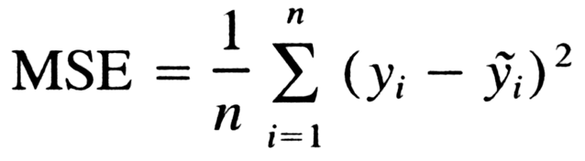

- n is the total number of data points (samples).
- 𝑦𝑖​ is the actual value of the 𝑖ith data point.
- 𝑦^𝑖 is the predicted value of the 𝑖ith data point.
- The sum is taken over all data points.

In simpler terms, you calculate the squared difference between each actual value 𝑦𝑖yi​ and its corresponding predicted value 𝑦^𝑖y^​i​, sum up these squared differences, and then divide by the total number of data points 𝑛n to get the average squared difference, which is the MSE.

